Project Design Phase-II
Technology Stack (Architecture & Stack)

Date | 29 June 2026
Team ID
Project Name | ONLINE COMPLAINT REGISTRATION
Maximum Marks | 4 Marks

Technical Architecture:
The Deliverable shall include the architectural diagram as below and the information as per the table1 & table 2
Architecture Diagram - ResolveHub (Online Complaint Registration)
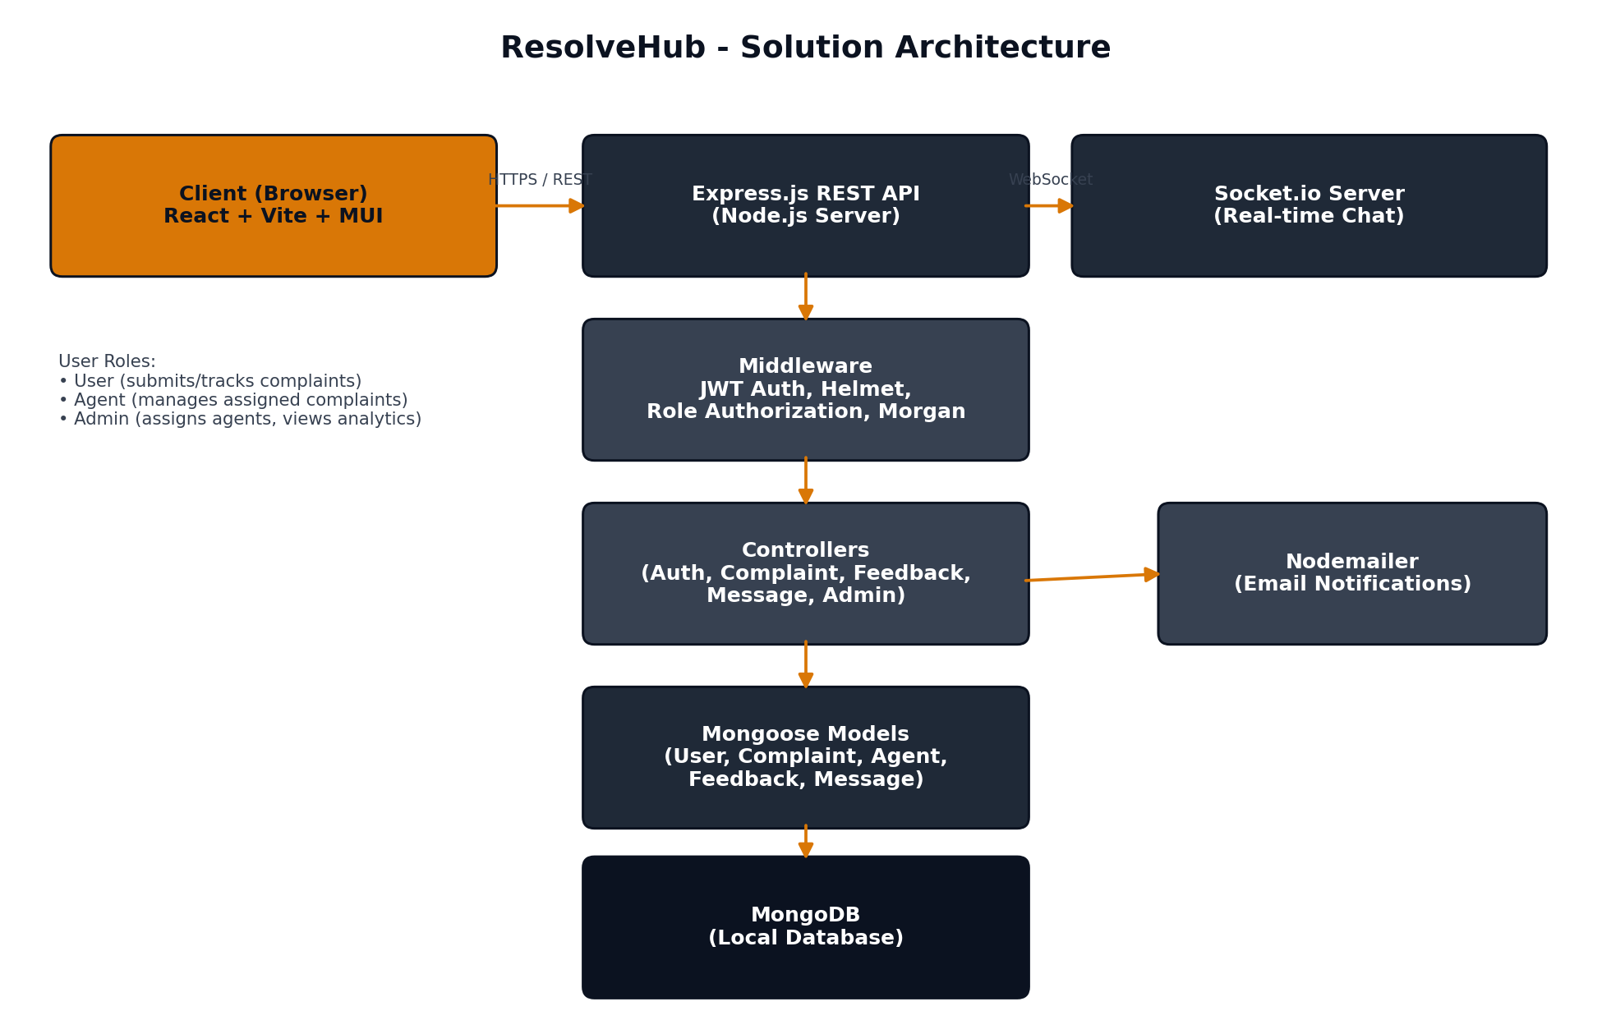
Example: Order processing during pandemics for offline mode
Reference: https://developer.ibm.com/patterns/ai-powered-backend-system-for-order-processing-during-pandemics/
Guidelines:
Include all the processes (As an application logic / Technology Block)
Provide infrastructural demarcation (Local / Cloud)
Indicate external interfaces (third party API’s etc.)
Indicate Data Storage components / services
Indicate interface to machine learning models (if applicable)


Table-1 : Components & Technologies:
S.No | Component | Description | Technology
1 | User Interface | Single-page application rendered in the browser, providing role-specific dashboards for User, Agent, and Admin | React.js 18 + Vite + Material UI (MUI)
2 | Frontend State Management | Global state for authenticated user and complaint context | React Context API (AuthContext, ComplaintContext)
3 | Frontend HTTP Client | Makes authenticated REST API calls with JWT bearer token injected via Axios interceptor | Axios
4 | Frontend Routing | Client-side routing with role-based protected routes | React Router DOM v6
5 | Application Logic – REST API | Handles authentication, complaint CRUD, agent assignment, feedback, and admin analytics via RESTful endpoints | Node.js + Express.js
6 | Application Logic – Real-time | Manages WebSocket connections for live chat between user and assigned agent, authenticated via JWT | Socket.io v4
7 | Authentication & Security | JWT token generation/verification, password hashing, and HTTP security headers | jsonwebtoken, bcryptjs, Helmet.js, CORS
8 | Email Notifications | Sends email alerts on complaint assignment and resolution | Nodemailer
9 | API Logging | Logs all incoming HTTP requests in development mode | Morgan
10 | Database | NoSQL document store for users, complaints, agents, feedback, and messages with Mongoose ODM for schema validation | MongoDB (local) + Mongoose
11 | Infrastructure (Server) | Local Node.js server; no cloud deployment required for demo. Can be migrated to any Node-compatible cloud. | Local (Node.js v18+) / Can deploy to Render, Railway, or Heroku

Table-2: Application Characteristics:
S.No | Characteristics | Description | Technology
1 | Open-Source Frameworks | React, Express.js, Mongoose, Socket.io, Axios, React Router, bcryptjs, Helmet, Morgan — all MIT/BSD licensed open-source packages | npm ecosystem
2 | Security Implementations | JWT for stateless auth (7-day expiry), bcrypt (10 salt rounds) for password hashing, Helmet for secure HTTP headers, CORS restricted to frontend origin, role-based middleware (403 on unauthorized routes), strong seed credentials | jsonwebtoken, bcryptjs, Helmet.js, CORS middleware
3 | Scalable Architecture | 3-tier MVC architecture: React SPA (Presentation) ↔ Express REST + Socket.io (Application/Controller) ↔ MongoDB (Data). Stateless JWT-based API allows horizontal scaling | MVC + Stateless REST + MongoDB
4 | Availability | Local MongoDB runs as a background service ensuring uptime during demos. All config externalized in .env, enabling seamless migration to MongoDB Atlas for cloud HA | Local MongoDB / MongoDB Atlas (cloud-ready)
5 | Performance | MongoDB indexes on status and email fields reduce query time; Vite tree-shaking minimizes JS bundle; Socket.io rooms scope messages to relevant participants only | MongoDB indexing, Vite build optimization, Socket.io rooms

References:
https://c4model.com/
https://developer.ibm.com/patterns/online-order-processing-system-during-pandemic/
https://www.ibm.com/cloud/architecture
https://aws.amazon.com/architecture
https://medium.com/the-internal-startup/how-to-draw-useful-technical-architecture-diagrams-2d20c9fda90d

